

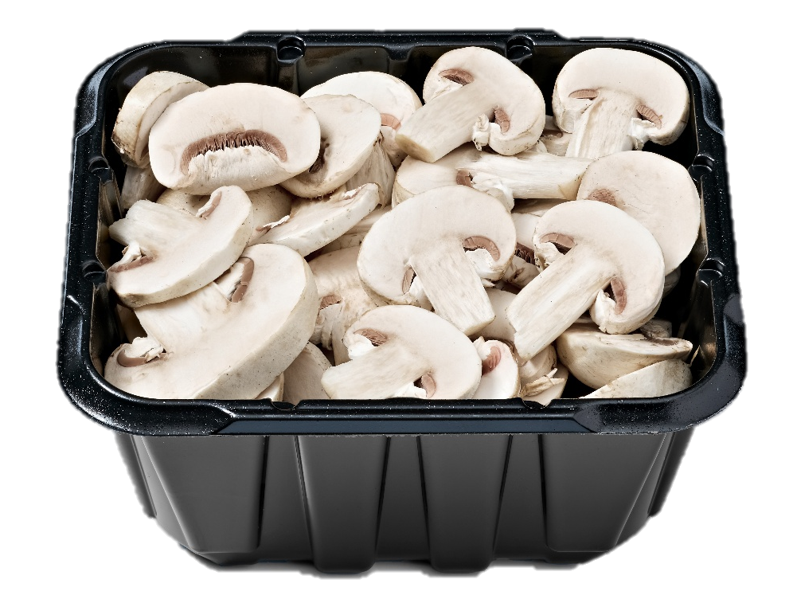
2026
Top Seller Report
An in-depth look at the sales and performance of the top 20 sellers in dollars, units and volume by pack size, type, organic versus conventional and whole versus sliced.

Developed by:
The Mushroom Council

Top Sellers in the U.S. Marketplace

Dollar View
8-ounce, white, sliced mushrooms are the top seller. Their $170.6 in annual sales represents 12.9% of total fresh mushroom dollar sales.
- This is closely followed by 8-ounce, white, whole mushrooms, representing 12.6% of total sales.
- Crimini mushrooms, in two 8-ounce and one 24-ounce packs close out the top five in dollar sales.
- Out of the top 20 sellers, seven are organic mushrooms.
- Additionally, seven of the top sellers are sliced versus whole mushrooms.
- Organic mushrooms represent 23.6% of total fresh mushroom dollar sales and whole mushrooms account for 59.6% of sales.

The top 20 represent 81.7% of total fresh mushroom dollar sales.

Fresh mushrooms | Package weight | Organic or conventional | Whole or prepared | Dollar rank | Dollar Sales | Share of total dollars
White mushrooms | 8 OZ | Conventional | Sliced | 1 | $170,643,286 | 12.9%
White mushrooms | 8 OZ | Conventional | No prep | 2 | $166,571,075 | 12.6%
Crimini/brown mushrooms | 8 OZ | Conventional | Sliced | 3 | $106,464,149 | 8.0%
Crimini/brown mushrooms | 8 OZ | Conventional | No prep | 4 | $85,646,727 | 6.5%
Crimini/brown mushrooms | 24 OZ | Organic | No prep | 5 | $85,044,638 | 6.4%
White mushrooms | 24 OZ | Conventional | No prep | 6 | $72,352,650 | 5.5%
White mushrooms | 16 OZ | Conventional | Sliced | 7 | $50,472,290 | 3.8%
Portabella mushrooms | 8 OZ | Conventional | No prep | 8 | $49,354,574 | 3.7%
White mushrooms | 16 OZ | Conventional | No prep | 9 | $44,613,750 | 3.4%
White mushrooms | 24 OZ | Organic | No prep | 10 | $37,598,014 | 2.8%
Crimini/brown mushrooms | 24 OZ | Conventional | No prep | 11 | $30,089,757 | 2.3%
Crimini/brown mushrooms | 16 OZ | Conventional | No prep | 12 | $28,481,443 | 2.2%
Crimini/brown mushrooms | 8 OZ | Organic | No prep | 13 | $25,530,892 | 1.9%
White mushrooms | 8 OZ | Organic | No prep | 14 | $23,844,611 | 1.8%
Crimini/brown mushrooms | 16 OZ | Conventional | Sliced | 15 | $23,078,193 | 1.7%
White mushrooms | 8 OZ | Organic | Sliced | 16 | $19,153,848 | 1.4%
White mushrooms | Random | Conventional | No prep | 17 | $18,805,591 | 1.4%
Shiitake mushrooms | 5 OZ | Organic | Sliced | 18 | $15,524,370 | 1.2%
Crimini/brown mushrooms | 8 OZ | Organic | Sliced | 19 | $14,786,663 | 1.1%
Crimini/brown mushrooms | 10 OZ | Conventional | No prep | 20 | $13,511,110 | 1.0%
Total mushrooms | TOTAL | TOTAL | TOTAL | N/A | $1,417,404,038 | 100.0%

Source: Circana, Integrated Fresh, Total US, MULO+ 52 weeks ending 4/19/2026

Unit View
8-ounce, white, whole mushrooms are the top seller in units. Their 83.3 million in annual unit sales represents 18.4% of total fresh mushroom unit sales.
- This is closely followed by 8-ounce, white, sliced mushrooms, representing 17.6% of total sales.
- Sliced and whole crimini mushrooms in 8-ounce packs are third and fourth.
- Portabella mushrooms close out the top five sellers in unit sales.
- Out of the top 20 sellers, six are organic mushrooms (one less than the top sellers in dollars).
- Six of the top sellers are sliced versus whole mushrooms (also one less than in the dollar chart).

The top 20 represent 86.8% of total fresh mushroom unit sales.

Fresh mushrooms | Package weight | Organic or conventional | Whole or prepared | Unit rank | Unit sales | Share of total units
White mushrooms | 8 OZ | Conventional | No prep | 1 | 83,267,109 | 18.4%
White mushrooms | 8 OZ | Conventional | Sliced | 2 | 79,835,316 | 17.6%
Crimini/brown mushrooms | 8 OZ | Conventional | Sliced | 3 | 41,827,294 | 9.2%
Crimini/brown mushrooms | 8 OZ | Conventional | No prep | 4 | 36,267,561 | 8.0%
Portabella mushrooms | 8 OZ | Conventional | No prep | 5 | 23,815,520 | 5.2%
White mushrooms | 24 OZ | Conventional | No prep | 6 | 16,098,312 | 3.5%
White mushrooms | 16 OZ | Conventional | Sliced | 7 | 15,829,409 | 3.5%
Crimini/brown mushrooms | 24 OZ | Organic | No prep | 8 | 15,217,145 | 3.4%
White mushrooms | 16 OZ | Conventional | No prep | 9 | 12,064,396 | 2.7%
White mushrooms | 8 OZ | Organic | No prep | 10 | 8,430,762 | 1.9%
Crimini/brown mushrooms | 8 OZ | Organic | No prep | 11 | 7,886,324 | 1.7%
White mushrooms | Random | Conventional | No prep | 12 | 7,228,274 | 1.6%
Crimini/brown mushrooms | 16 OZ | Conventional | No prep | 13 | 6,952,508 | 1.5%
White mushrooms | 8 OZ | Organic | Sliced | 14 | 6,690,679 | 1.5%
White mushrooms | 24 OZ | Organic | No prep | 15 | 6,621,243 | 1.5%
Crimini/brown mushrooms | 24 OZ | Conventional | No prep | 16 | 5,991,346 | 1.3%
Crimini/brown mushrooms | 16 OZ | Conventional | Sliced | 17 | 5,462,284 | 1.2%
Crimini/brown mushrooms | 10 OZ | Conventional | No prep | 18 | 4,886,192 | 1.1%
Crimini/brown mushrooms | Random | Conventional | No prep | 19 | 4,679,923 | 1.0%
Crimini/brown mushrooms | 8 OZ | Organic | Sliced | 20 | 4,590,980 | 1.0%
Total mushrooms | TOTAL | TOTAL | TOTAL | N/A | 472,392,076 | 100.0%

Source: Circana, Integrated Fresh, Total US, MULO+ 52 weeks ending 4/19/2026

Volume View
Selling 41.6 million pounds annually, 8-ounce, white, whole mushroom packages are the top seller in pound sales.
- This is closely followed by 8-ounce, white, sliced mushrooms, representing 13.2% of total sales.
- 24-ounce packages have overtaken 8-ounce offerings in third and fourth place. This includes a 24-ounce white conventional whole mushroom pack and a 24-ounce crimini, whole organic mushroom pack.
- The top five is rounded out by an 8-ounce sliced conventional crimini pack.
- Out of the top 20 sellers, five are organic mushrooms and seven are sliced versus whole mushrooms.

The top 20 represent 87.2% of total fresh mushroom pounds sales.

Fresh mushrooms | Package weight | Organic or conventional | Whole or prepared | Volume rank | Volume sales | Share of total volume
White mushrooms | 8 OZ | Conventional | No prep | 1 | 41,633,555 | 13.8%
White mushrooms | 8 OZ | Conventional | Sliced | 2 | 39,917,658 | 13.2%
White mushrooms | 24 OZ | Conventional | No prep | 3 | 24,147,468 | 8.0%
Crimini/brown mushrooms | 24 OZ | Organic | No prep | 4 | 22,825,718 | 7.6%
Crimini/brown mushrooms | 8 OZ | Conventional | Sliced | 5 | 20,913,647 | 6.9%
Crimini/brown mushrooms | 8 OZ | Conventional | No prep | 6 | 18,133,780 | 6.0%
White mushrooms | 16 OZ | Conventional | Sliced | 7 | 15,765,643 | 5.2%
White mushrooms | 16 OZ | Conventional | No prep | 8 | 12,062,797 | 4.0%
Portabella mushrooms | 8 OZ | Conventional | No prep | 9 | 11,907,760 | 4.0%
White mushrooms | 24 OZ | Organic | No prep | 10 | 9,931,864 | 3.3%
Crimini/brown mushrooms | 24 OZ | Conventional | No prep | 11 | 8,987,019 | 3.0%
Crimini/brown mushrooms | 16 OZ | Conventional | No prep | 12 | 6,952,468 | 2.3%
Crimini/brown mushrooms | 16 OZ | Conventional | Sliced | 13 | 5,462,284 | 1.8%
White mushrooms | 8 OZ | Organic | No prep | 14 | 4,215,381 | 1.4%
White mushrooms | Random | Conventional | No prep | 15 | 4,010,236 | 1.3%
Crimini/brown mushrooms | 8 OZ | Organic | No prep | 16 | 3,943,162 | 1.3%
White mushrooms | 8 OZ | Organic | Sliced | 17 | 3,345,340 | 1.1%
Crimini/brown mushrooms | 10 OZ | Conventional | No prep | 18 | 3,053,870 | 1.0%
White mushrooms | 12 OZ | Conventional | Sliced | 19 | 2,957,540 | 1.0%
White mushrooms | 20 OZ | Conventional | Sliced | 20 | 2,757,552 | 0.9%
Total mushrooms | TOTAL | TOTAL | TOTAL | N/A | 317,474,445 | 100.0%

Source: Circana, Integrated Fresh, Total US, MULO+ 52 weeks ending 4/19/2026

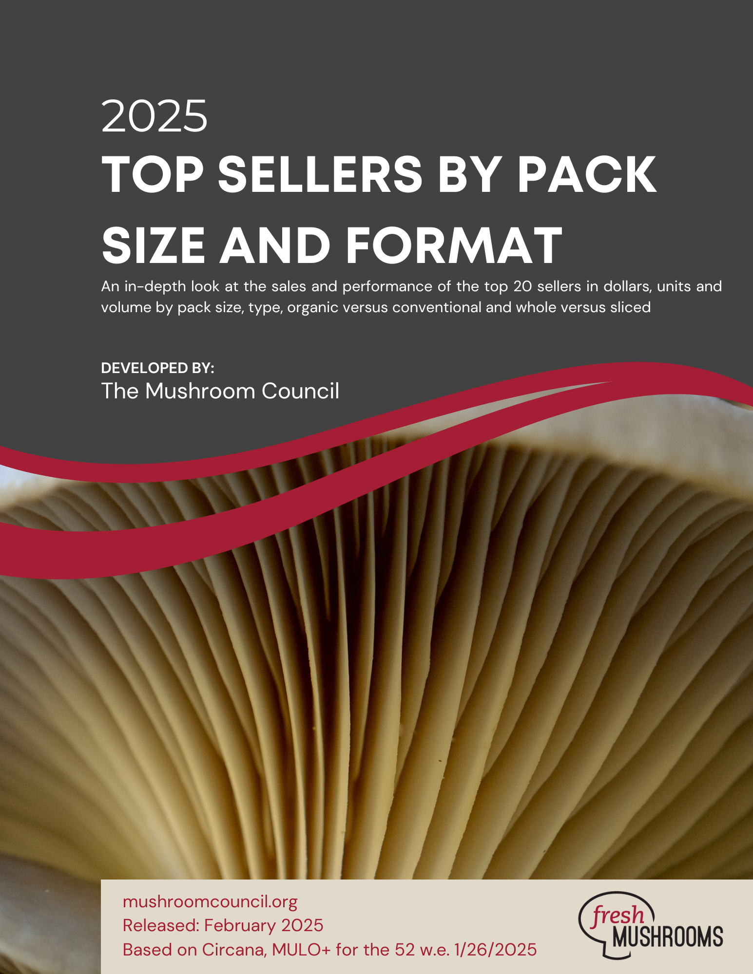
Top Sellers in 2021
8-ounce, white, sliced mushrooms were the top seller in pounds in 2021, representing 14.4% of total fresh mushroom pounds sold at retail.
- This is compared to 13.8% today.
- White mushrooms were more dominant in 2021, taking up the number one, two and four slots in volume.
- In 2021, fewer top sellers were organic, at six packages versus seven in 2026.

The top 20 represent 87.2% of total fresh mushroom pounds sales in 2021.

Fresh mushrooms | Package weight | Organic or conventional | Whole or prepared | Dollar sales | Unit sales | Volume sales | Share of volume sales
White mushrooms | 8 OZ | Conventional | Sliced | $214,849,630 | 105,294,293 | 52,647,145 | 14.4%
White mushrooms | 8 OZ | Conventional | No prep | $185,811,360 | 98,888,859 | 49,444,430 | 13.5%
Crimini/brown mushrooms | 8 OZ | Conventional | Sliced | $114,960,735 | 45,380,515 | 22,690,257 | 6.2%
White mushrooms | 16 OZ | Conventional | Sliced | $98,568,169 | 33,648,625 | 33,647,208 | 9.2%
Crimini/brown mushrooms | 8 OZ | Conventional | No prep | $79,022,956 | 34,062,134 | 17,031,067 | 4.6%
Crimini/brown mushrooms | 24 OZ | Organic | No prep | $74,510,508 | 15,064,878 | 22,597,317 | 6.2%
White mushrooms | 24 OZ | Conventional | No prep | $60,542,467 | 14,394,660 | 21,592,020 | 5.9%
Portabella mushrooms | 8 OZ | Conventional | No prep | $57,641,353 | 26,093,826 | 13,046,914 | 3.6%
White mushrooms | 16 OZ | Conventional | No prep | $56,447,999 | 16,288,027 | 16,287,829 | 4.4%
White mushrooms | 24 OZ | Organic | No prep | $41,661,870 | 8,087,974 | 12,131,961 | 3.3%
Crimini/brown mushrooms | 24 OZ | Conventional | No prep | $37,104,974 | 8,222,419 | 12,333,629 | 3.4%
Crimini/brown mushrooms | 16 OZ | Conventional | No prep | $36,739,681 | 9,861,262 | 9,861,244 | 2.7%
Crimini/brown mushrooms | 16 OZ | Conventional | Sliced | $33,629,905 | 8,348,591 | 8,348,591 | 2.3%
White mushrooms | Random | Conventional | No prep | $30,375,160 | 11,100,237 | 5,653,262 | 1.5%
Crimini/brown mushrooms | 8 OZ | Organic | No prep | $28,709,930 | 9,693,383 | 4,846,692 | 1.3%
Shiitake mushrooms | 5 OZ | Conventional | Sliced | $27,693,665 | 5,908,671 | 1,846,460 | 0.5%
White mushrooms | 8 OZ | Organic | No prep | $25,229,207 | 9,374,091 | 4,687,046 | 1.3%
Crimini/brown mushrooms | 8 OZ | Organic | Sliced | $21,134,326 | 7,097,904 | 3,548,952 | 1.0%
White mushrooms | 8 OZ | Organic | Sliced | $20,302,100 | 7,590,747 | 3,795,374 | 1.0%
Portabella mushrooms | 8 OZ | Conventional | Sliced | $17,034,676 | 7,157,290 | 3,578,645 | 1.0%
Total mushrooms | TOTAL | TOTAL | TOTAL | $1,498,456,597 | 552,644,852 | 366,580,198 | 100.0%

Source: Circana, Integrated Fresh, Total US, MULO+, calendar year 2021

Top Sellers in Specialty and Mixed Variety Mushrooms
5-ounce, organic sliced shiitake mushrooms are the top seller in dollars, units and pounds among the specialty and mixed variety packs.
- The top seller posted dollar, unit and volume growth in the past year.
- Other packages with year-over-year growth include a mixed four-ounce sliced package and a four-ounce sliced shiitake.
- While random weight makes one occurrence in the top 10 sellers, sales are down by double digits in the past year.
- Three of the top 10 specialty mushroom sellers are organic and six are sliced versus whole.

Fresh mushrooms | Package weight | Organic or conventional | Whole or prepared | Dollar sales | Unit sales | Volume sales
Shiitake | 5 OZ | Organic | Sliced | $15,524,370 | 2,788,117 | 871,287
Shiitake | 5 OZ | Conventional | Sliced | $13,447,829 | 2,783,543 | 869,857
Chanterelle | 16 OZ | Conventional | No prep | $6,918,032 | 547,755 | 547,755
Mixed | 4 OZ | Conventional | Sliced | $3,939,960 | 1,066,041 | 266,510
Shiitake | 3.5 OZ | Conventional | No prep | $3,018,371 | 669,547 | 147,092
Shiitake | 10 OZ | Conventional | Sliced | $2,438,643 | 306,055 | 191,285
Shiitake | 4 OZ | Organic | Sliced | $2,411,727 | 502,555 | 125,639
Shiitake | Random | Conventional | No prep | $2,237,622 | 609,073 | 328,509
Shiitake | 3.5 OZ | Conventional | Sliced | $1,763,310 | 419,210 | 91,723
Shiitake | 3.5 OZ | Organic | No prep | $1,688,894 | 357,977 | 78,325

Source: Circana, Integrated Fresh, Total US, MULO+ 52 weeks ending 4/19/2026

Additional notes
The spreadsheet also provides access to the biggest seller data by region.
- Click on the region of interest.
- The data is currently sorted by dollar sales, but can be sorted by units, volume, etc. using the sort function in Excel.
- Using the filters you can select particular varieties, pack sizes or formats.

For more information or assistance, please contact the Mushroom Council: info@mushroomcouncil.org.

