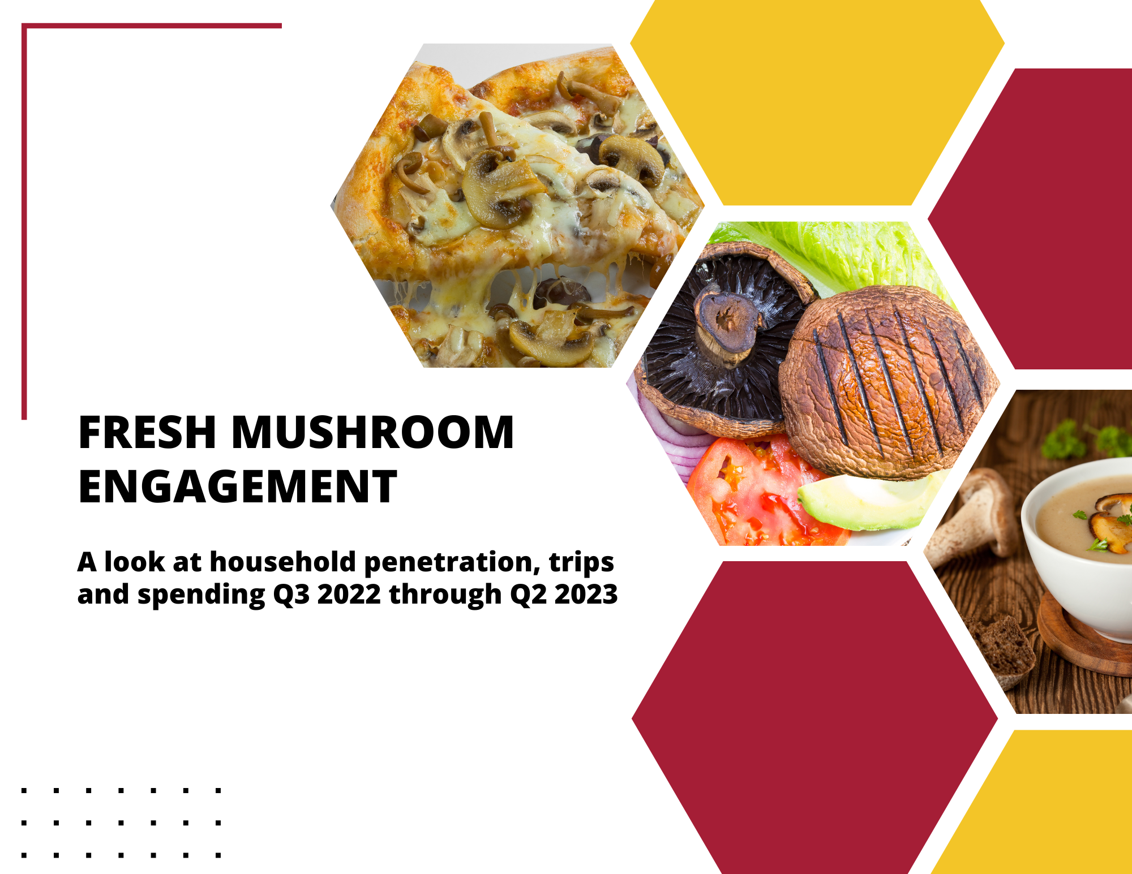

Q3 2022 – Q2 2023 Mushroom Engagement at Retail
Every department, category or item ultimately has three ways in which it can grow: an increase in the number of people who purchase the item, an increase in the number of times it is purchased, and an increase in the trip spend by buying a larger size or more premium item. In the first half of 2023, prices for food and beverages bought at retail continued to increase and unit and volume pressure persisted across categories. Mushrooms have experienced above-average pressure and a look at shopper engagement provides some of the answers.

Household penetration
The pressure on income has prompted many consumers to buy less, resulting in decreased household penetration for many categories, including produce. Out of the top 15 sellers in fresh vegetables, only cucumbers managed a slight increase of 0.3% in household penetration. All others, including staples such as potatoes, onions, tomatoes and lettuce experienced a reduction in the number of households that bought the item at least once. The 1.6% decline in household penetration for mushrooms was the third-highest, behind celery and squash.

Source: Circana (formerly IRI), Integrated Fresh Household Panel, all outlets, 52 weeks ending 7/16/2023

Annual trips per Buyer
Total vegetable trips changed slightly, with upticks for several of the large trip drivers, including tomatoes, onions, cucumbers and potatoes. That meant slightly more than 52 shopping trips per year, averaging about one fresh produce purchase per week. Mushrooms averaged 7.3 shopping trips over the past 52 weeks, which was virtually unchanged. Given the decrease in household penetration, trip frequency is an important focus.

Source: Circana (formerly IRI), Integrated Fresh Household Panel, all outlets, 52 weeks ending 7/16/2023

Dollars per Trip
All categories but squash experienced increases in the spend per trip in in the latest 52 weeks. The increases were highest for potatoes, given substantial inflation, followed by lettuce, salad kits and broccoli. Inflation was the biggest, and in many cases the sole driver behind the increase in the basket ring. Among those who purchased mushrooms in the past year, spending increased by 11 cents per trip. However, the average price per unit increased 15 cents. That means that households who continued to purchase mushrooms increased their per trip purchase at a rate slightly below the level of unit inflation.

Source: Circana (formerly IRI), Integrated Fresh Household Panel, all outlets, 52 weeks ending 7/16/2023

Annual spend per buyer
The combination of more trips and a higher spend per trip prompted an increase of $12.06 spent on fresh produce per buyer in the past year. Fresh mushrooms were different. Given the slight reduction in trips and mild increase in the spend per trip, average annual spend per buyer increased $0.45. The increase in annual spending was highest for potatoes, with an additional $5.72, followed by lettuce, at +$3.30.

Source: Circana (formerly IRI), Integrated Fresh Household Panel, all outlets, 52 weeks ending 7/16/2023

Comparison of latest 52 weeks (Q3 2022-Q2 2023) versus year-ago levels
At 48.2%, household penetration for mushrooms was the 11th highest among all vegetables. The big staples including potatoes, onions, tomatoes and lettuce dominate household penetration.

Product | Latest 52 weeks ending 7/16/2023
 | % HH Buying | % HH Buying Change vs YA | Dollars per Buyer | Dollars per Buyer Change vs YA | Dollars per Trip | Dollars per Trip Change vs YA | Product Trips per Buyer | Product Trips per Buyer Change vs YA
Total vegetables | 97.7 | -0.1 | $333.16 | $12.06 | $6.31 | $0.20 | 52.8 | 0.2
Potatoes | 85.0 | -0.3 | $39.79 | $5.72 | $4.04 | $0.52 | 9.8 | 0.2
Onions | 83.1 | -0.6 | $28.80 | $2.57 | $2.02 | $0.16 | 14.2 | 0.2
Tomatoes | 80.1 | -0.8 | $44.27 | $1.96 | $2.88 | $0.12 | 15.4 | 0.1
Lettuce | 79.8 | -0.7 | $34.55 | $3.30 | $3.06 | $0.31 | 11.3 | (0.1)
Carrots | 77.4 | -0.7 | $15.37 | $0.50 | $2.04 | $0.11 | 7.5 | (0.2)
Peppers | 71.9 | -0.6 | $30.70 | $0.54 | $2.68 | $0.06 | 11.5 | (0.1)
Cucumbers | 63.8 | 0.3 | $20.93 | $1.70 | $1.92 | $0.09 | 10.9 | 0.4
Celery | 62.7 | -1.8 | $12.32 | $0.82 | $2.20 | $0.17 | 5.6 | (0.1)
Salad kits | 51.2 | -1.1 | $50.86 | ($0.13) | $6.26 | $0.22 | 8.1 | (0.3)
Broccoli | 51.2 | -0.6 | $21.93 | $1.04 | $2.99 | $0.20 | 7.3 | (0.1)
Mushrooms | 48.2 | -1.6 | $23.58 | $0.45 | $3.23 | $0.11 | 7.3 | (0.1)
Spinach | 46.8 | -1.3 | $19.35 | ($0.38) | $3.25 | $0.10 | 6.0 | (0.3)
Squash | 46.7 | -1.7 | $15.52 | ($0.30) | $2.70 | ($0.01) | 5.7 | 0.1
Corn | 46.0 | -1.3 | $13.11 | $0.77 | $2.79 | $0.13 | 4.8 | 0.1
Cabbage | 42.0 | -0.9 | $9.82 | $0.75 | $2.32 | $0.10 | 4.2 | 0.1

Conclusion
Given the pressure on the number of households purchasing mushrooms at retail in the past few years, optimizing trips and the spend per trip moves into the forefront. This means connecting with current heavy and medium buyers, who drive the vast majority of trips and represent the vast majority of fresh mushroom dollars.

