First Quarter 2023 Organic Mushroom Performance

The Marketplace
Inflation has profoundly changed grocery shopping patterns. The organic produce segment is not immune to the tremendous economic pressure even though core organic shoppers tend to be high-income households. Much like the rest of the produce department, organic dollar sales increased over 2022, but pounds decreased by 2.5%.

In the first quarter of 2023, organic fresh produce sales represented 10.5% of dollar sales and 6.8% of pound sales, due to an above-average price per pound. Vegetables have an above-average share of organic sales, at 14.2% of dollars and 7.0% of pound sales.
Source: Circana, Integrated Fresh, Total US, 52 weeks ending 3/26/2023

During the first 13 weeks of 2023, conventional sales outperformed organic in both total produce and vegetables. Organic experienced a decline in dollars, units and volume whereas conventional still managed to grow dollar sales due to inflation. Additionally, the declines seen in organic produce sales exceeded those seen in conventional.

Q1 2023 | Produce department |  |  |  | Vegetables
 | Total | Conventional | Organic | Total |  | Conventional | Organic
Dollar Sales | $18.5B | $16.6B | $2.0B | $9.4B |  | $8.2B | $1.2B
Dollar share | 100.0% | 89.5% | 10.5% | 100.0% |  | 87.2% | 14.2%
Dollars vs. YA | 1.3% | 1.7% | -1.8% | 3.5% |  | 4.2% | -0.9%
Dollars vs. 2YA | 6.8% | 7.3% | 2.4% | 3.9% |  | 4.4% | 0.5%
Dollars vs. 3YA | 11.9% | 12.1% | 11.0% | 8.8% |  | 8.6% | 9.6%
Unit Sales | 7.1B | 6.5B | 0.6B | 3.9B |  | 3.6B | 0.4B
Unit share | 100.0% | 91.7% | 8.3% | 100.0% |  | 90.5% | 9.5%
Units vs. YA | -1.5% | -1.2% | -5.0% | -3.3% |  | -3.0% | -6.1%
Units vs. 2YA | -5.6% | -5.5% | -6.1% | -9.2% |  | -9.3% | -8.4%
Units vs. 3YA | -3.1% | -3.3% | 0.2% | -5.9% |  | -6.4% | -0.7%
Volume Sales | 9.5B | 8.8B | 0.7B | 4.6B |  | 4.3B | 0.3B
Volume share | 100.0% | 93.2% | 6.8% | 100.0% |  | 93.0% | 7.0%
Volume vs. YA | -2.0% | -1.6% | -5.9% | -2.9% |  | -2.6% | -6.7%
Volume vs. 2YA | -6.0% | -5.9% | -6.6% | -7.9% |  | -7.8% | -8.5%
Volume vs. 3YA | -5.7% | -5.8% | -3.9% | -6.9% |  | -7.0% | -6.3%

Source: Circana, Integrated Fresh, Total US, 52 weeks ending 3/26/2023

Shoppers who purchase organic produce at much higher rates include:
- Millennials
- Households with children at home
- Living in urban areas
- Living in the West and Northeast

Source: FMI, Power of Produce 2023

Organic produce predictions | All organic shoppers
Buy more in the next year | 30%
Buy about the same | 51%
Buy less in the next year | 19%
Expected purchases of organic produce in the next year show that the strength and potential growth would come from current core consumers with few new households entering the organic space. That is a typical pattern seen during inflationary and recessionary times.

Source: FMI, Power of Produce 2023

Organic Mushroom First Quarter Sales Findings
The performance for conventional and organic fresh mushrooms bucks the overall produce and vegetable trends. During the first quarter of 2023, organic mushroom dollar sales increased by 0.7%, whereas conventional sales decreased 9.2%. It is important to note that retailers making assortment-related shifts can influence the subsequent performance numbers.

Fresh mushrooms — dollars | Latest 52 wks | $ share | Vs. YA | Vs. 2YA | Vs. 3YA
Total | $316.6 million | 100.0% | -7.9% | -13.2% | -5.8%
Conventional | $271.5 million | 85.8% | -9.2% | -15.3% | -7.8%
Organic | $45.1 million | 14.2% | +0.7% | +2.7% | +8.9%
Source: Circana, Integrated Fresh, MULO, YTD and 13 weeks ending 3/26/2023

Volume patterns show the influence of inflation on organic mushrooms’ positive dollar performance, with pounds down 11.9% versus the first quarter of 2022. This is, however, slightly better than the -13.6% seen for conventional mushrooms.
Fresh mushrooms — pounds | Latest 52 wks | $ share | Vs. YA | Vs. 2YA | Vs. 3YA
Total | 66.4 million | 100.0% | -13.4% | -22.2% | -17.1%
Conventional | 59.3 million | 89.3% | -13.6% | -23.0% | -17.9%
Organic | 7.1 million | 10.7% | -11.9% | -15.0% | -9.7%
Source: Circana, Integrated Fresh, MULO, YTD and 13 weeks ending 3/26/2023

Organic fresh mushroom unit sales were also down less than their conventional counterparts. A comparison in movement between pounds and units over the past year shows that organic had a slightly higher decrease in pounds versus units — signaling a switch to smaller pack sizes.

Fresh mushrooms — units | Latest 52 wks | $ share | Vs. YA | Vs. 2YA | Vs. 3YA
Total | 103.5 million | 100.0% | -15.3% | -23.4% | -20.5%
Conventional | 91.2 million | 88.1% | -16.1% | -24.7% | -21.7%
Organic | 12.4 million | 11.9% | -9.3% | -12.3% | -9.5%
Source: Circana, Integrated Fresh, MULO, YTD and 13 weeks ending 3/26/2023

Organic Performance by Mushroom Type
Organic crimini mushrooms are the biggest seller, at $16.6 million, followed by organic whites. Growth is seen for organic shiitake mushrooms, but this is on a relatively small base.

Organic mushrooms | Dollars Q1 2023 | Vs. YA | Vs. 2YA | Vs. 3YA | Pounds  Q1 2023 | Vs. YA | Vs. 2YA | Vs. 3YA
Total | $45.1 million | +0.7% | +2.7% | +8.9% | 7.1 million | -11.9% | -15.0% | -9.7%
Crimini | $16.6 million | -1.1% | -1.5% | +8.6% | 2.8 million | -21.7% | -25.0% | -12.7%
White | $15.9 million | -3.7% | -6.3% | -5.9% | 3.2 million | -3.3% | -6.5% | -7.2%
Shiitake | $6.5 million | +54.9% | +188.6% | +296.3% | 0.4 million | +43.2% | +161.4% | +245.8%
Portabella | $4.5 million | -14.3% | -23.6% | -28.5% | 0.5 million | -19.3% | -32.2% | -39.7%
Source: Circana, Integrated Fresh, MULO, YTD and 13 weeks ending 3/26/2023

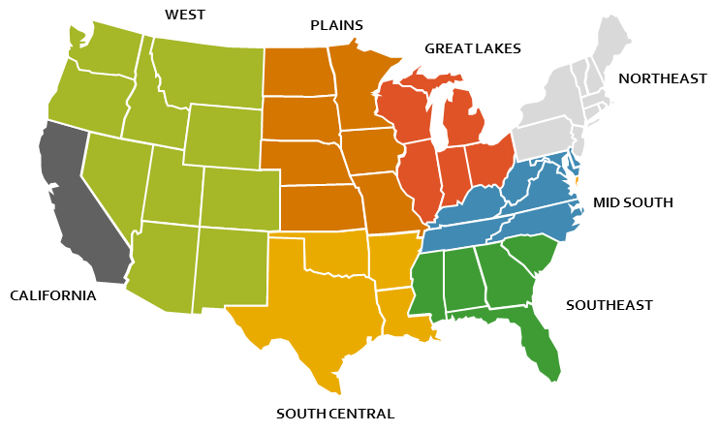
Organic Mushroom Regional Performance
Circana divides the nation into nine areas, that are quite different in size. To provide a benchmark for the size of each region, the first column shows the share of total vegetable dollars. In comparison to the share of total vegetable dollars, areas that over index for organic vegetable sales are California, the Northeast and the West.

When comparing the regional mushroom shares to the regional vegetable shares, areas with an above-average share are California, the Great Lakes, the Northeast and the West. Regions with an above average share of organic mushroom sales versus their overall mushroom share include California, the Great Lakes and the West. The large dollar increase in the southeastern region may point to an assortment switch from conventional to organic for one of the Southeastern retailers.

 | Share of vegetable $ | Share of  organic vegetable $ | Share of mushrooms | Share of organic mushrooms | Organic mushroom $ growth
Total US | 100.0% | 100.0% | 100.0% | 100.0% | +0.7%
California | 11.5% | 14.1% | 12.9% | 15.2% | -7.9%
Great Lakes | 13.0% | 12.6% | 14.8% | 32.8% | -2.1%
Mid-South | 13.2% | 12.3% | 12.0% | 8.8% | -0.8%
Northeast | 17.9% | 19.6% | 18.5% | 10.1% | -7.6%
Plains | 6.5% | 4.3% | 6.0% | 2.4% | +1.1%
South Central | 9.1% | 6.5% | 6.7% | 3.1% | -3.9%
Southeast | 16.1% | 14.5% | 13.6% | 10.2% | +66.4%
West | 12.8% | 16.0% | 15.5% | 17.2% | -2.4%

Source: Circana, Integrated Fresh, 4 weeks ending 2/26/2023

= Above-average growth performance
= Above-average share of organic vs. total and mushrooms vs. vegetables

Conclusion
Unlike total produce and vegetables, organic mushroom sales performed conventional in the first quarter of 2023. However, gaps by type and regional were substantial signaling a very uneven performance.

Helpful Hints
This information can be found in the quad-week retail tracker reports, using the organic sales tab. Information can be found for:
- Three time periods, including four, thirteen and 52 weeks.
- The various mushroom times, including aggregates for white, brown (the combination of crimini and portabellas) and exotics, which includes shiitake, oyster, etc. mushrooms.
- The total U.S., the nine Circana regions and the major markets.

