
Live.Balanced and Plant Forward
Social Media Posts

It’s easy to add more plant foods to your daily meals if you start by focusing on fruits and vegetables. Experiment with all the different varieties that can be found across our store – from canned tomatoes and beans to frozen whole berries and a huge variety of fresh apples. With so many delicious options it’s easy to fill half your plate with plants! #LiveBalancedNGA #PlantForward
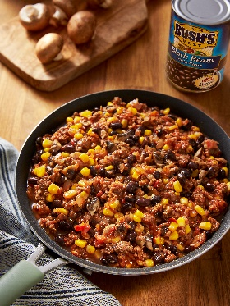
Looking for family-friendly dinner ideas? Lean ground beef + BUSH’S® Black Beans + chopped mushrooms and onions makes a delicious plant-forward mealtime starter that can be used in several recipes! Shop____________ (insert retailers name) where we have all ingredients and recipes at hand. #LiveBalancedNGA #PlantForward
Note to retailer: add link to Plant-Powered Black Bean and Beef Blend recipe.

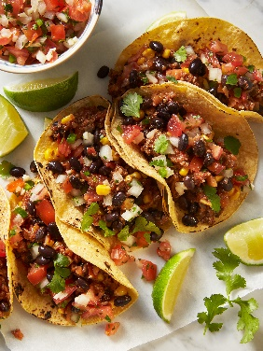
Discover how our tasty blend of lean meat, beans, mushrooms & onions can be made once and used in several recipes like tacos, Mexican lasagna, power bowls or stuffed peppers. Visit our in-store demo between ___________ (insert time range) today for a sample and recipes! #PlantForward #LiveBalancedNGA #BushsBeans #enjoyonions #MushroomCouncil

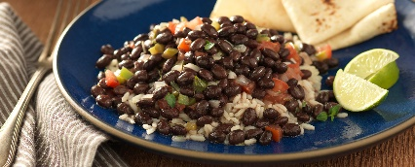
Plant-forward eating simply means emphasizing & celebrating more plant foods at meals. This classic Black Bean & Rice dish is a perfect example - 10 minutes and done! #PlantForward #LiveBalancedNGA #BushsBeans #enjoyonions

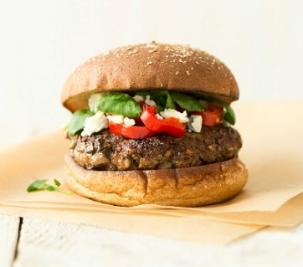
The Blend™ adds mushrooms to meat and mushrooms add flavor, veggies and an earth-friendly ingredient – one tasty way to eat more plant-forward!
#PlantForward #LiveBalancedNGA #MushroomCouncil

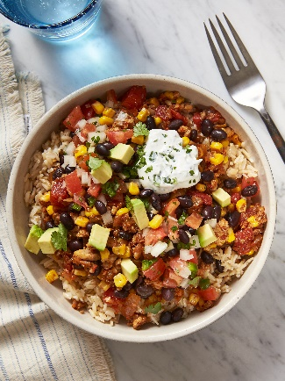
Add more plants to your favorite recipes with this blend of lean poultry, beans, mushrooms & onions. Perfect for tacos, meat loaf, chili and more! Just cook once and eat twice!
#PlantForward #LiveBalancedNGA #BushsBeans #MushroomCouncil #enjoyonions
Note to retailer: add link to Plant-Powered Black Bean and Chicken Blend recipe.

Want to be powered by more plant foods? Then think of yourself as a flexitarian – flexing your recipes and snack choices to include more plants. For example - add veggies to scrambled eggs at breakfast, include a salad for lunch, enjoy fruit for dessert and keep your desk stocked with nuts as an afternoon snack. #LiveBalancedNGA #PlantForward

BUSH’S® Black Beans are a versatile, convenient ingredient for more plant-forward meals. Add them to soups, stews, chili, Mexican dishes, salads, salsa and more. Bonus - they’re packed with protein and fiber! #PlantForward #LiveBalancedNGA #BushsBeans


The Onion is Nature’s Ninja – for health, nutrition, taste & sustainability! Learn more: https://youtu.be/f8AZkvfyJrQ #PlantForward #LiveBalancedNGA #naturesninja

Caramelized onions add fantastic flavor to plant-forward meals and recipes! Use them to top your sandwich, salad, or add to dips, soups, stews, eggs & pasta. Master the basic technique with this video -https://www.youtube.com/watch?v=-WSOblQY4L4 and try them in this delicious Caramelized Sweet Onion Hummus – just add veggie dippers! #PlantForward #LiveBalancedNGA #enjoyonions
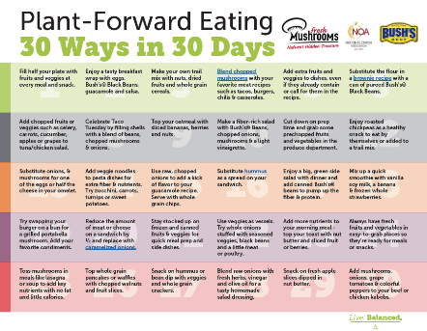
Adding more plants to your meals can be healthier for you and the planet! Check out our month of easy tips for eating plant-forward - 30 Ways in 30 Days. #PlantForward #LiveBalancedNGA #BushsBeans #MushroomCouncil #enjoyonions
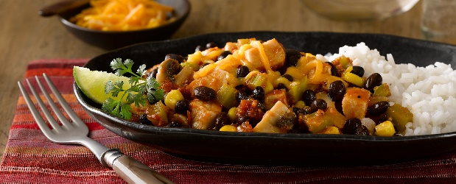
If you are a meat-lover, there’s no need to remove it from plant-forward meals, just pair it with plant foods. In this Salsa-Chicken Skillet, spiced chicken and BUSH’S® Black Beans pair up with lots of veggies for a quick weeknight dinner.
#PlantForward #LiveBalancedNGA #BushsBeans #MushroomCouncil #enjoyonions

Did you know that mushrooms are a nutrition powerhouse? They contain potassium, B-vitamins, antioxidants and are the only source of Vitamin D in the produce aisle! Pick some up today at _______________ (insert retailer’s name) and add them to your favorite recipes. #PlantForward #LiveBalancedNGA #MushroomCouncil

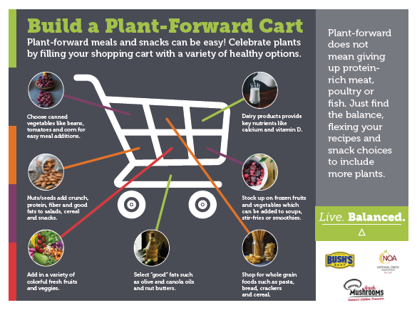
Plant-forward meals and snacks can be easy! Simply start by filling your shopping cart with a variety of healthy plant foods. #PlantForward #LiveBalancedNGA #BushsBeans #MushroomCouncil #enjoyonions

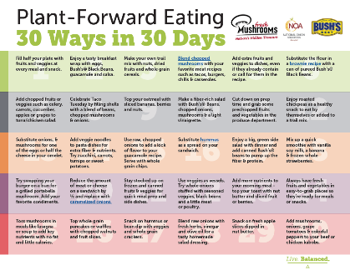
Adding small amounts of plant-based foods throughout the day can make a big difference in how you feel today and, in the future. Simply add a little here and there. Try hummus as a sandwich spread. Add onions, mushrooms and colorful peppers to kebobs. Replace part of the flour in your favorite brownie recipe with pureed BUSH’S® Black Beans. For more tips click here (Note to retailer: add link to 30 Ways in 30 Days). #PlantForward #LiveBalancedNGA #BushsBeans #MushroomCouncil #enjoyonions

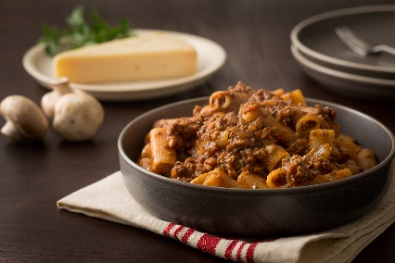
Trying to make meals more delicious, nutrition and sustainable with plant-forward recipes? Blend finely chopped fresh mushrooms with lean ground meat to create the Blend™. We love it in this Blended Pasta Sauce – perfect for an easy weeknight dinner! #PlantForward #LiveBalancedNGA #MushroomCouncil

Does a plant-forward eating pattern mean you’re a vegetarian or vegan? Not always. Plant-forward eating habits celebrate more plant foods in meals and snacks. Think about adding beautiful fruits and vegetables, hearty beans, whole grains, and crunchy nuts to daily eating habits. But you can still enjoy meat, poultry and fish if you’d like, just shift the balance to include more plant-based foods. #LiveBalancedNGA #PlantForward #HaveAPlant
Note to retailer: Add link to Celebrating Plants on Your Plate article.

More plant foods in your shopping cart may lead to better health! Plant-forward eating habits tend to be higher in vitamins, minerals and antioxidants, and can have a positive impact on weight management, while lowering your risk of heart disease, high blood pressure, diabetes & certain cancers. Our plant-forward shopping cart can help you discover those plant foods that have the best nutrition. #LiveBalancedNGA #PlantForward #HaveAPlant

