Live.Balanced. and Plant Forward
BLOG/E-NEWSLETTER/NEWSPAPER CONTENT

The following content can be used as a blog on your website or in an e-newsletter you send to your loyal shoppers. If your store has pharmacies, consider printing copies of one of the articles and making them available when shoppers pick up prescriptions. Local newspapers are frequently looking for content related to health and pitching them on one of these articles can draw new customers to your stores.

Article #1
Should you Jump on the Plant-forward Bandwagon?
Celebrities are doing commercials that promote plant-based burgers. #plantbased is trending in social media. Your co-workers keep inviting you to lunch at vegetarian restaurants. But you still question whether you should join the plant-forward team.

It’s completely understandable. We’re here to answer your questions about the plant-forward movement.

Isn’t this the same as being a vegetarian or vegan?
Actually, it’s not. Plant-forward eating habits celebrate plants and emphasize them in meals and snacks. Think about adding beautiful fruits and vegetables, hearty beans and whole grains, and crunchy nuts to daily eating habits. It doesn’t mean giving up meat, poultry and fish, just shifting the balance to enjoy more plant-based foods. Vegetarian eating habits, on the other hand, don’t include any meat, fish or poultry; some vegetarians do consume eggs and dairy. Vegans avoid all animal products.

Does this mean I need to start drinking almond milk and eating plant-based yogurt?
You can if you like, but there are many natural plant foods that are delicious and add important nutrients to your eating habits. The Blend, for example, is a cooking technique that combines chopped mushrooms with ground meat to make meals more delicious, nutritious and sustainable. Beans are easy and convenient to add to meals and they help you get the fiber and protein you need to feel your best every day. Adding BUSH’S® Canned Beans to salads, chili, soup, pasta dishes or your favorite Mexican meal is an easy way to add more plants to your meals.

“When trying some of the newer plant-based products in the grocery store, it’s important ensure they are nutritionally equivalent to products they replace,” comments registered dietitian Shari Steinbach. She adds, “milk, for example, is an important source of calcium and vitamin D in eating habits, so you want to ensure the plant-based alternatives have calcium as well as vitamin D added to them.”

Fill your plate with produce, good fats from foods like canola oil and avocados, whole grains, beans, and nuts and seeds which are natural plant-based foods.

Is eating plant-forward healthier?
Plant-forward eating habits tend to be lower in saturated fat and cholesterol and higher in vitamins, minerals and antioxidants, and can positively impact risk of heart disease, high blood pressure, diabetes, certain cancers, and weight management.¹ But it’s important to consider the type of plant foods and their sources. Choose whole grains like brown rice and whole grain bread or crackers most of the time. Similarly, eating more whole fruit, will provide fiber and better satisfies your hunger. When adding plants, choose those that have the best nutrition.

Some experts suggest that using more plants in your recipes and meals can benefit the planet. Continued research is needed in this area, especially as more farmers and ranchers continue to update their practices.

Where do I start?
Think of yourself as a flexitarian – flexing your recipes and snack choices to include more plants. For example, add our Plant-Powered Chicken Blend recipe to scrambled eggs at breakfast or a salad for lunch. Keep your desk stocked with nuts as an afternoon snack. Choose fruit for dessert.

“An easy place to start is by focusing on fruits and vegetables,” says Steinbach. She recommends individuals experiment with all the different varieties in this category. Onions come in red, yellow and white, each with different flavors, textures and best uses. There are more than 16 different types of squash and as many as 2,500 varieties of apples. “With all the variety in produce, it’s easy to fill half your plate with plants!” Steinbach adds.

Source:
- Craigs, WJ, Mangels, AR. Position of the American Dietetic Association: Vegetarian Diets. J Am Diet Assoc. 2009 Jul;109(7):1266-82.

Note to Retailer: Include the Plant-Powered Chicken Blend recipe with this blog post.

Article #2
How to Build a Plant-Forward Shopping Cart
A plant-forward eating pattern that includes a variety of the right foods can help you manage your weight, reduce chronic inflammation and reduce your risk of heart disease, type 2 diabetes and stroke.^{1,2} In addition, eating more plant foods can have a positive impact on the environment. Plant-forward eating habits can also provide plenty of protein as meat can be included and many plant foods are good sources of protein.

Affordable, nutritious and delicious plant foods can be found throughout our store. Start by making sure fruits and veggies have a prominent place in your cart, and remember, they come in a variety of forms including fresh, frozen and canned. Pick those that are versatile recipes ingredients like mushrooms and onions. The canned food aisle is also a great place to stock up on BUSH’S® Beans which can be added to soups, chili, salads and more. Don’t forget to add a variety of whole grain foods along with nuts and seeds. And remember, lean meats, low fat dairy foods and seafood can also be part of plant-forward cart.

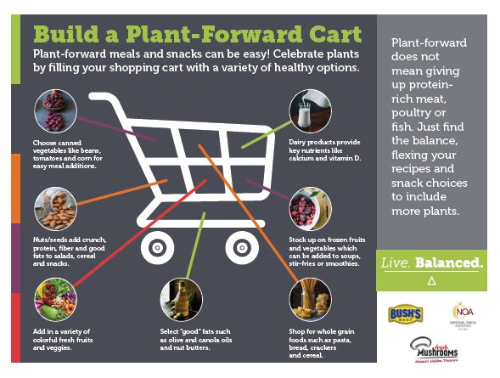
If you’re passionate about adding the healthy benefits of plant foods to your wellness routine, start by building a plant-forward shopping cart at _______________ (add in retailer’s name). As you’ll see, healthier choices abound in all departments!

Use this easy diagram to help you build a plant-forward shopping cart.

Source:
- Craigs, WJ, Mangels, AR. Position of the American Dietetic Association: Vegetarian Diets. J Am Diet Assoc. 2009 Jul;109(7):1266-82.

Article #3
Celebrating Plants on Your Plate
Celebrating is a word most often associated with holidays, significant birthdays or milestone events in the journey of life. But at ____________ (insert retailer name), we like to celebrate the thousands of plant-based foods available in our stores and how they enrich our lives every day. “Eating habits that include more plants are often higher in healthful and sustainable foods like vegetables, fruits, whole grains, nuts and seeds,” says registered dietitian Annette Maggi. “These eating habits provide key nutrients, can be lower in calories, and potentially more friendly to the planet.”
Plant-forward eating doesn’t mean you have to give up meat. In fact, the flavors and nutrients in plants can complement those found in meat, poultry and fish. For example, protein in poultry or fish combines with the fiber in vegetables and whole grains to make you feel full longer. The umami flavor of mushrooms complements similar flavors in meat. “The goal is to find the balance, celebrating plants by moving them to the center of the plate instead of using them in supporting roles,” says Maggi.
Here are tips on how to celebrate plants in meals throughout the week:
- Use veggies as vessels. Stuff it or top it; using vegetables as vessels will definitely get your family’s attention. Try whole peppers stuffed with seasoned onions, mushrooms, celery and squash or any vegetables you have left over from a previous dinner or with our Plant Powered Beef Blend recipe. Use sweet potatoes as your new taco shell. Stuff ricotta and parmesan cheese and pasta sauce into zucchini cut lengthwise to create zucchini boats or into portabella mushrooms for a meaty dinner.
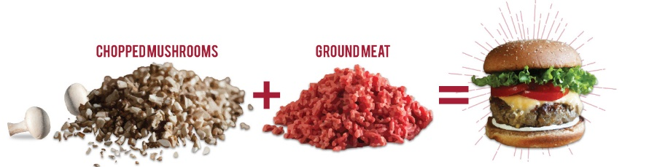
- Blend it. The Blend is a cooking technique that combines chopped mushrooms with ground meat to make meals more delicious, nutritious and sustainable. Try adding chopped mushrooms like white button or crimini, to ground meat in your burgers, pasta sauces and tacos to reduce fat and calories while still maintaining the meaty flavor you love.
- Cook once, use all week. Cooking large batches of whole grains like brown rice, quinoa, barley and oats in advance makes it more convenient to add them to daily meals. Oatmeal can be warmed and topped with fruit and nuts for a plant-powered breakfast. Quinoa can be prepacked with black beans, onions, arugula and avocado for savory lunch bowls. BUSH’S® Seasoned Recipe Black Beans pack a flavor punch, making this lunch option so easy to prepare and enjoy.
- Be adventurous. There are so many new uses of veggies like zucchini and sweet potato noodles and grilled or broiled cauliflower steaks (top with pasta sauce, onions, mushrooms, and parmesan cheese) that are fun to explore. Common foods that come in unique colors, like purple carrots and new flavor profiles in fruits, like Cotton Candy grapes, can encourage kids to eat more plant-based foods.
- Add a little here and there. Try hummus as a sandwich spread. Add onions, mushrooms and colorful peppers to kebobs. Replace part of the flour in your favorite brownie recipe with BUSH’S® Black Beans. Adding small amounts of plant-based foods throughout the day can make a big difference in how you feel today and in the future.
Look for these foods and thousands of plant-forward choices throughout _______________ (insert retailer name) stores.
Note to Retailer: Include the Plant-Powered Beef Blend recipe with this blog post.

